**LAB#11**

**Object:** Analysis of digital filter using MATLAB tools.

**TASK #01:**

Design LPF with 11th filter length , fc = 0.25khz ,fs =8khz .Use rectangular ,hamming & hanning window method.

**FILTER DESIGN & ANALYSIS TOOL:**

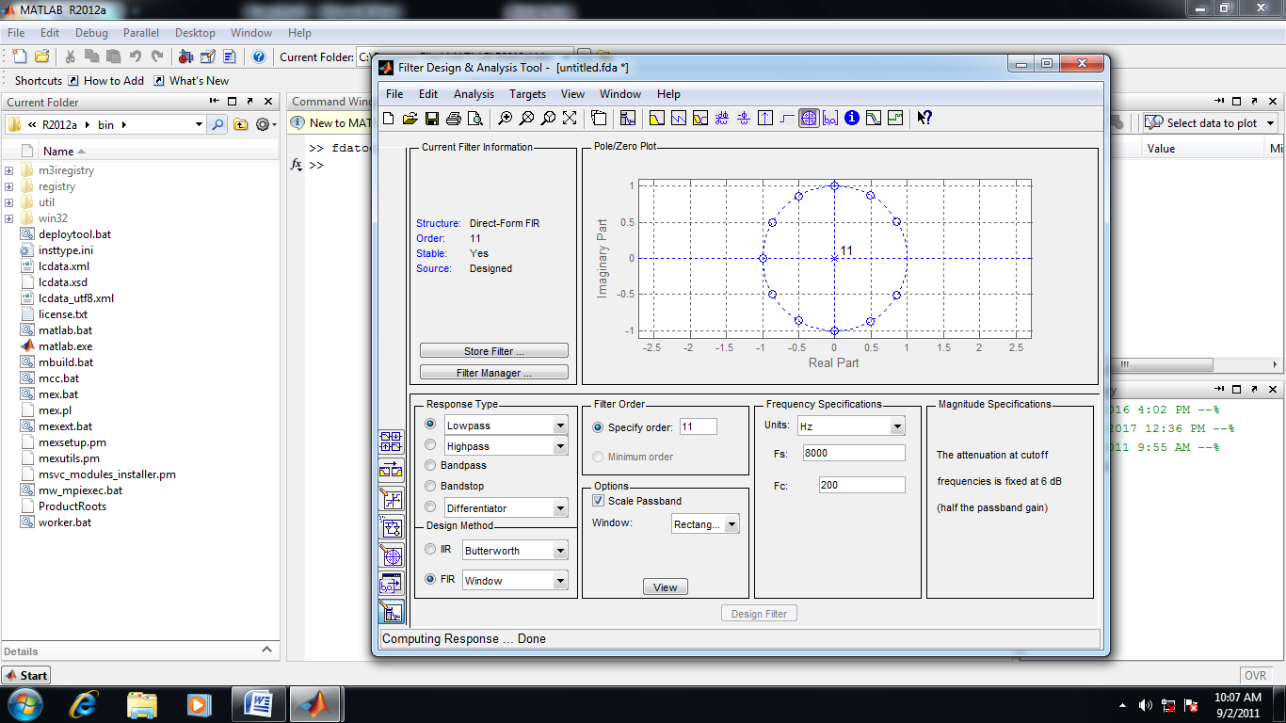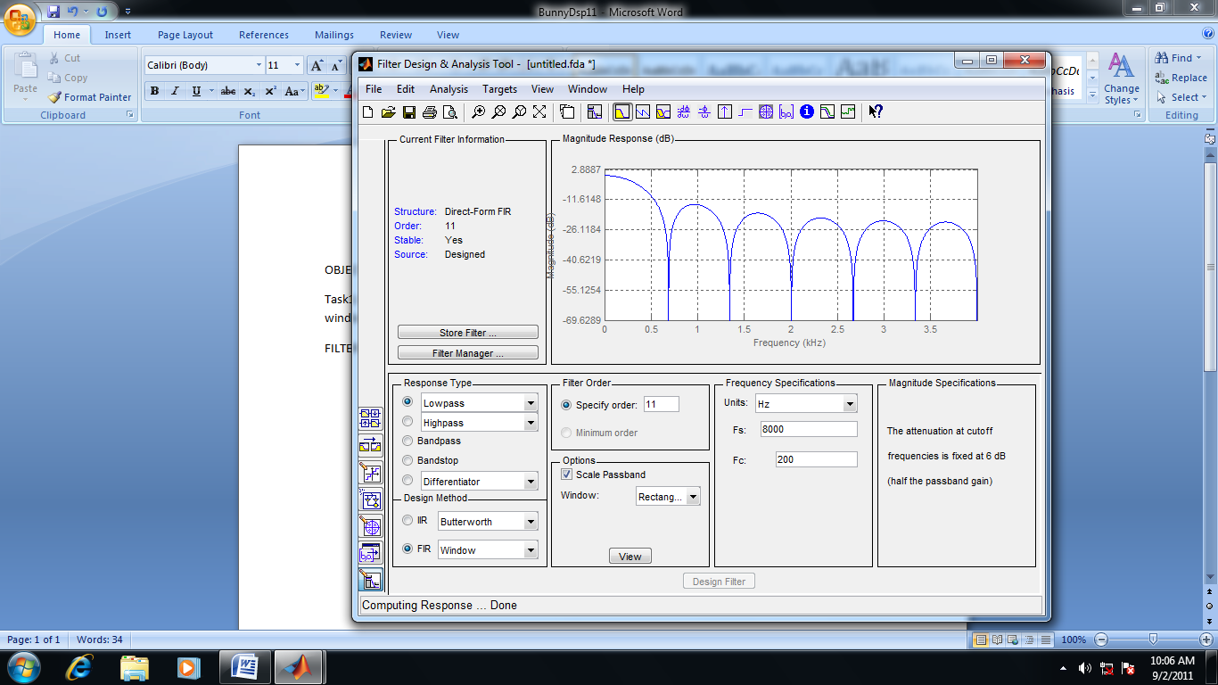**RECTANGULAR:**

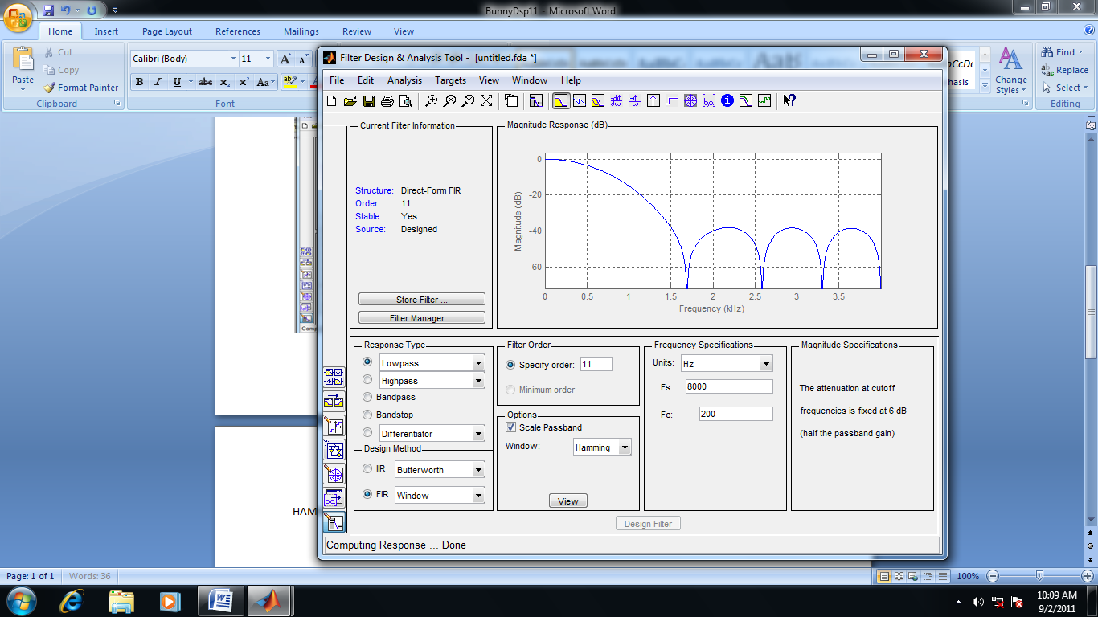**HAMMING:**

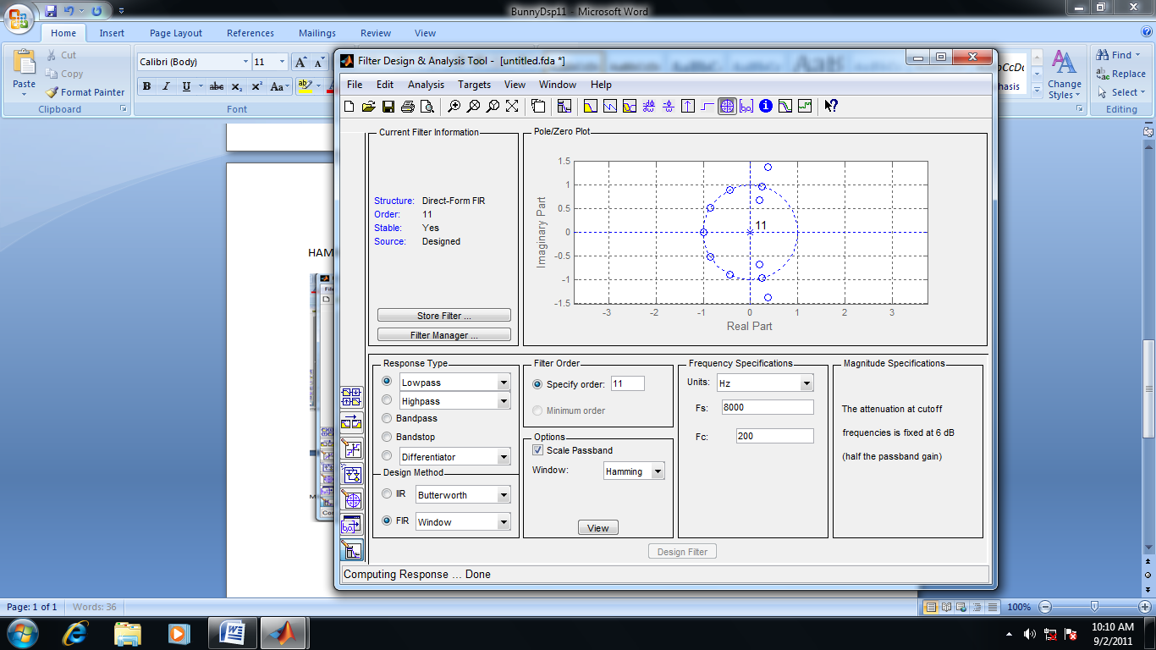

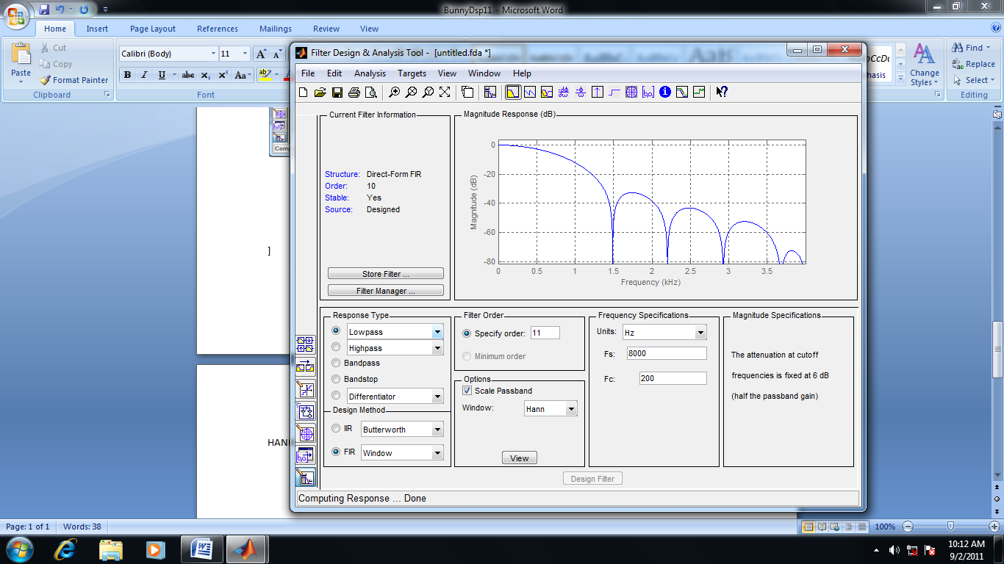**HANNING:**

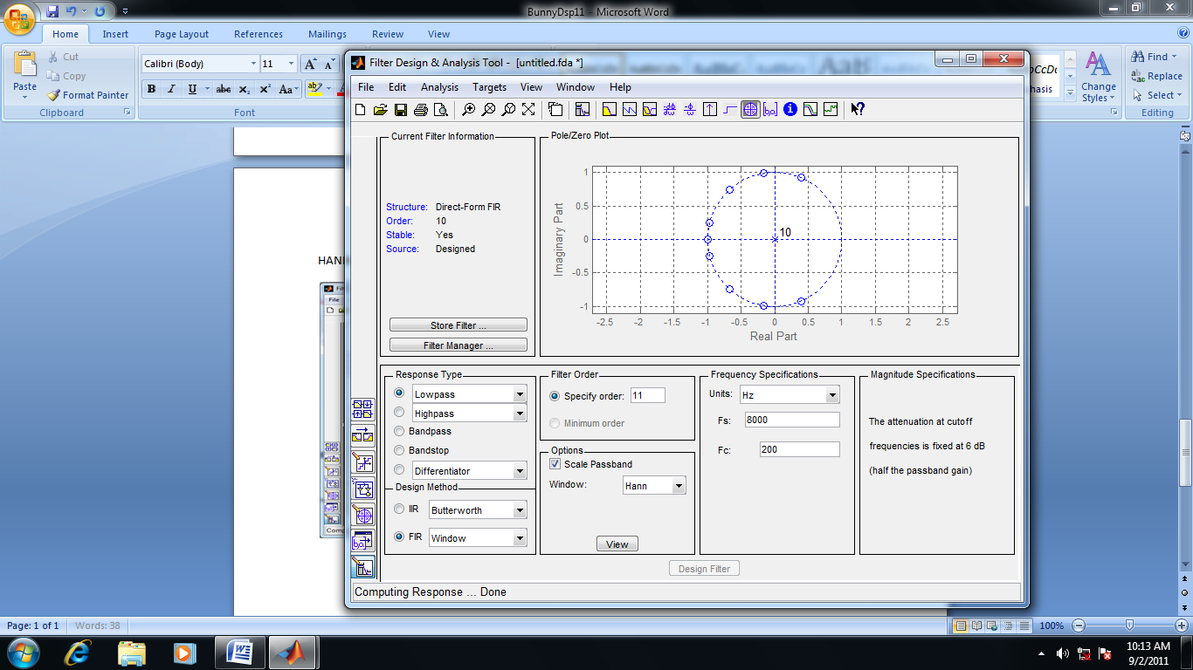

**TASK#02:**

Design High Pass filter to meet the following specifications

Fc=250hz, fs=1khz, fillters length = 8.

**FILTER DESIGN & ANALYSIS TOOL:**

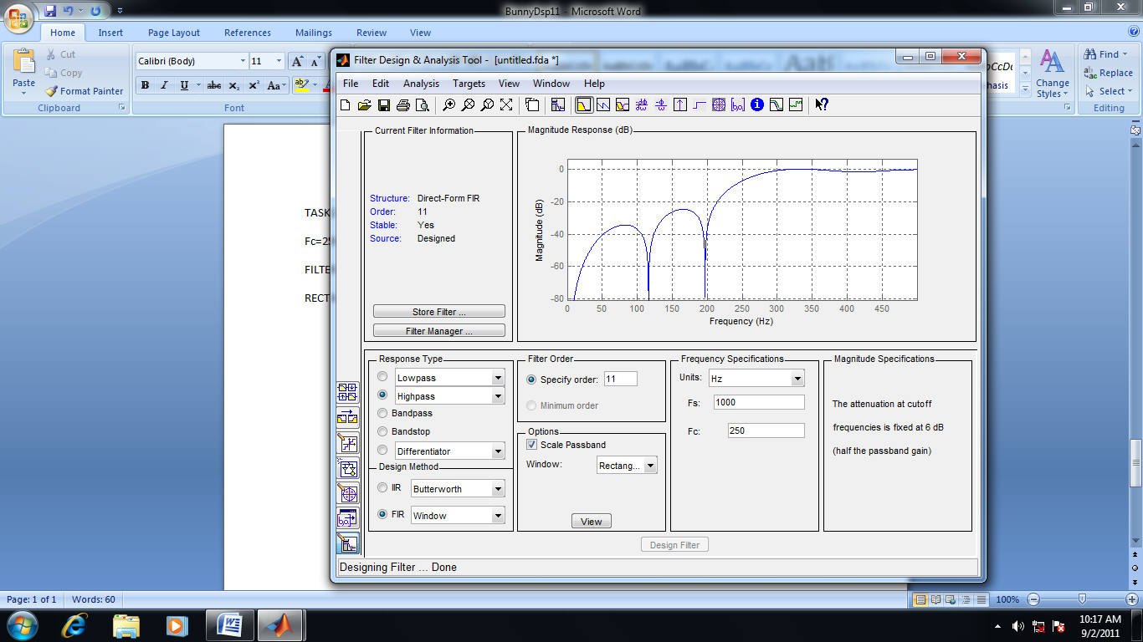**RECTANGULAR:**

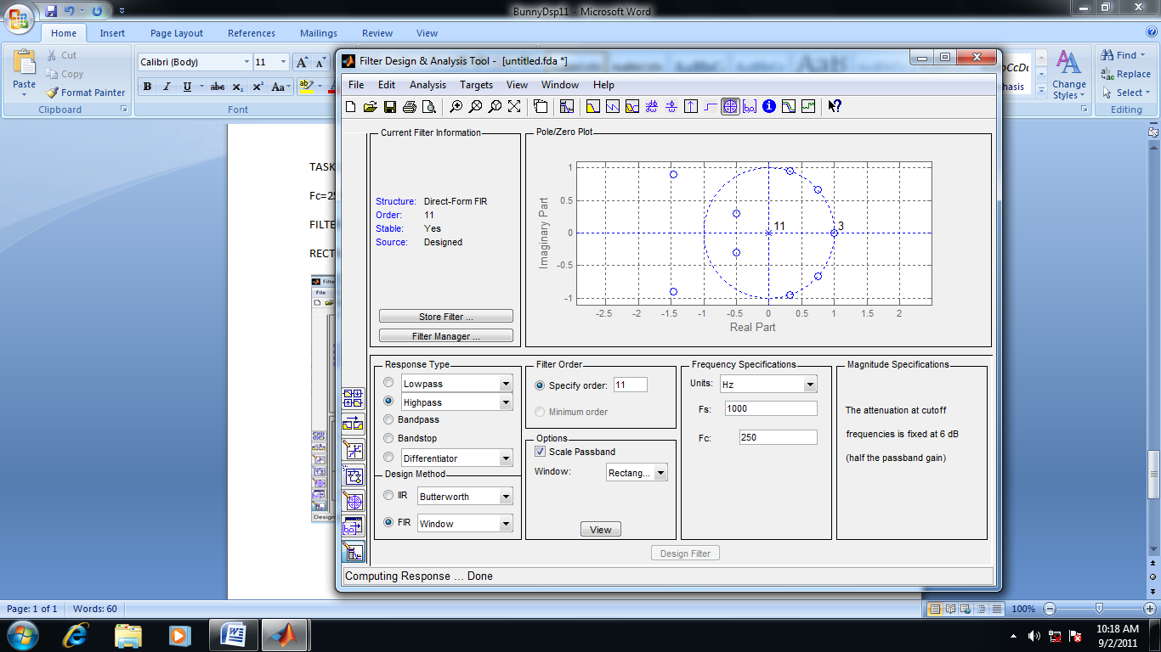

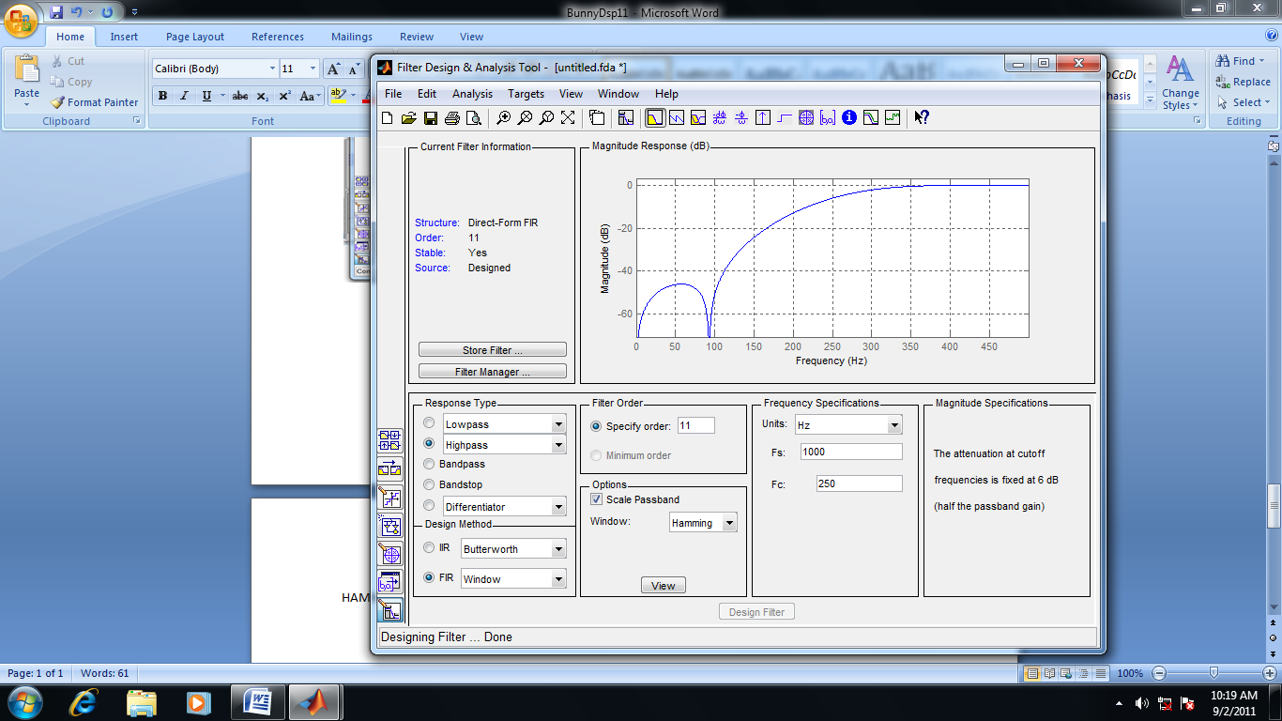**HAMMING:**

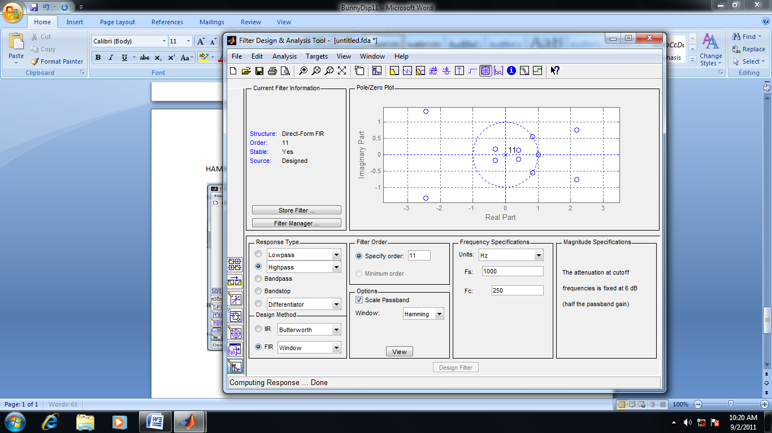

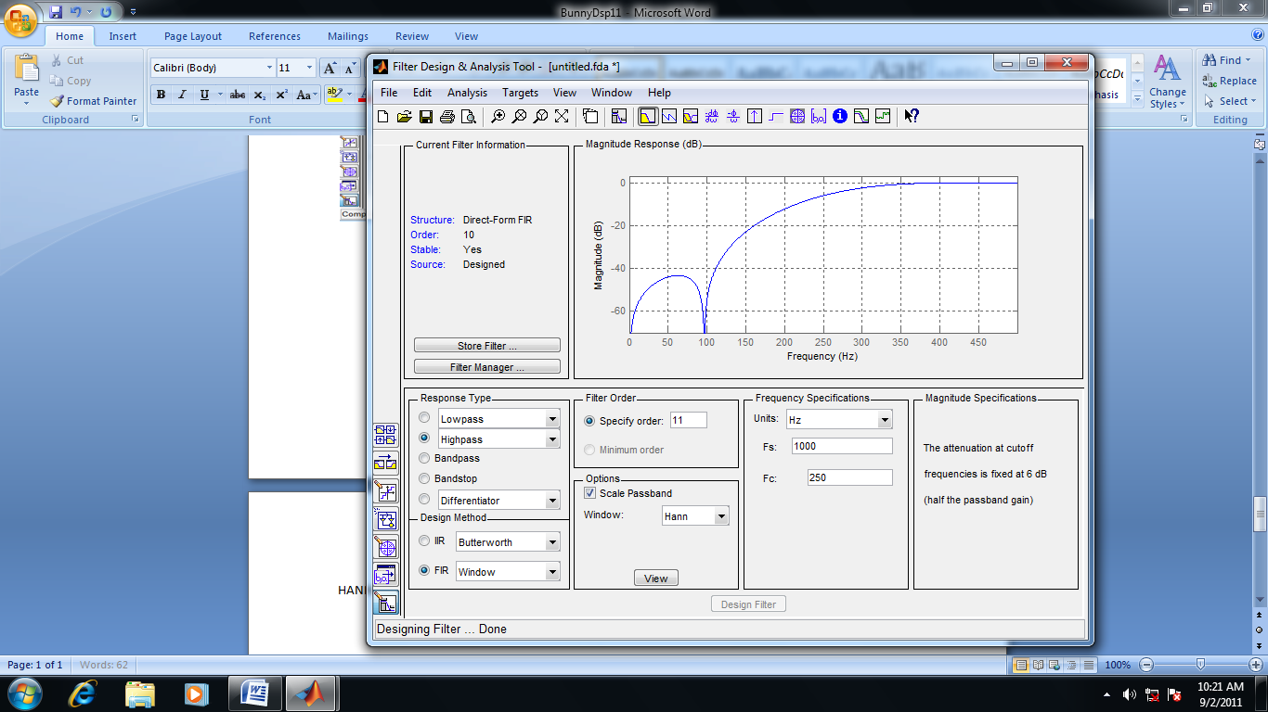**HANNING:**

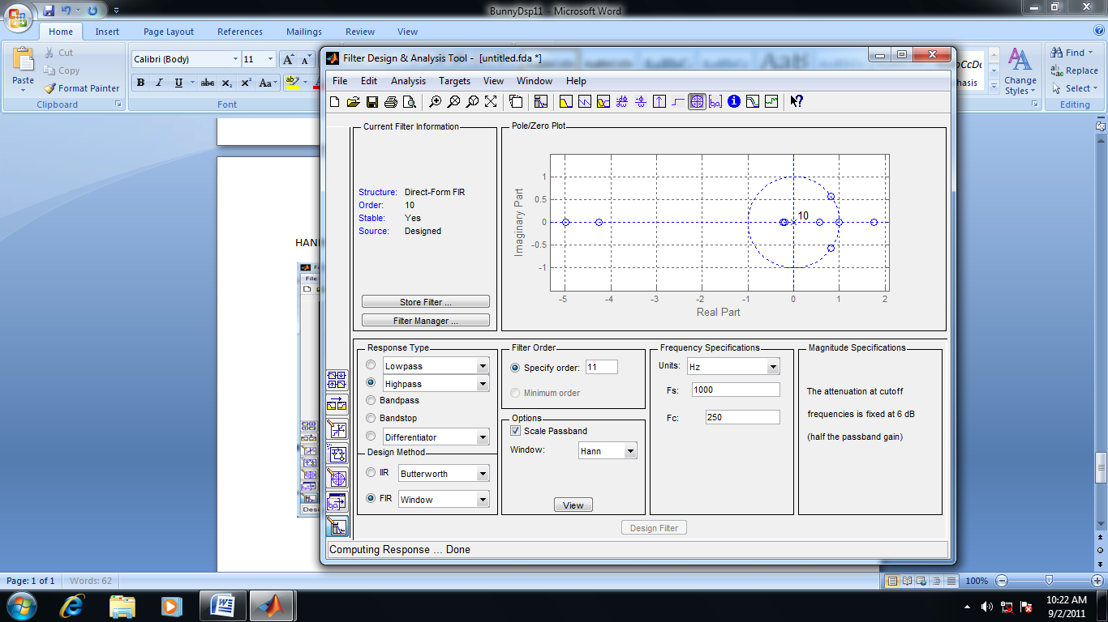

**TASK3**:

Design a bandpass filter for following specifications:

Fc1 = 100Hz , fc2 = 200 hz ,fs = 1khz & N=9.

**FILTER DESIGN & ANALYSIS TOOL:**

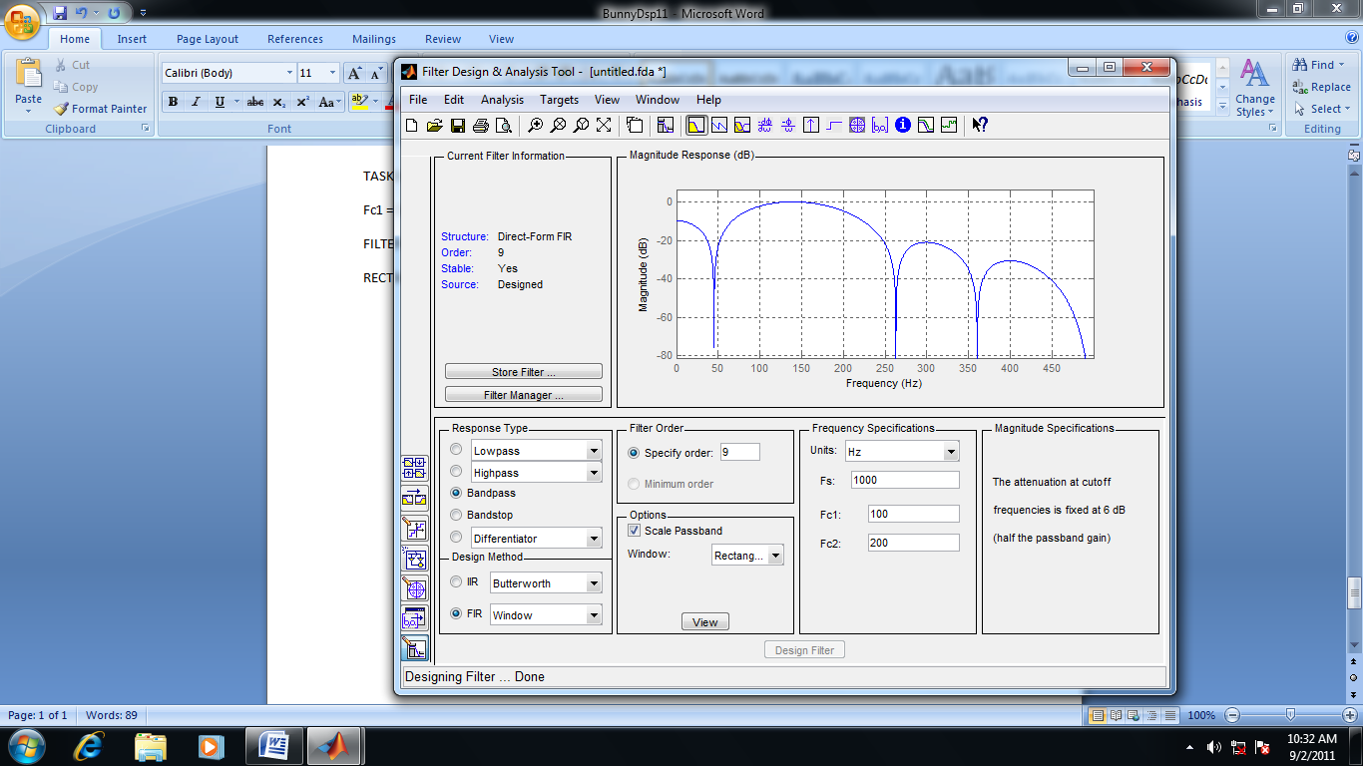**RECTANGULAR:**

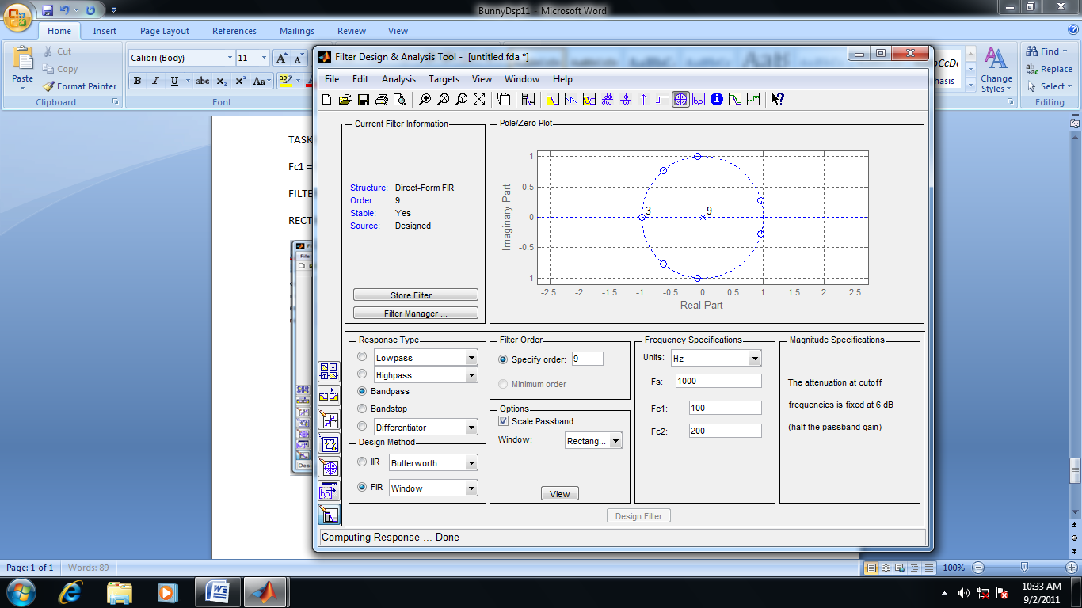

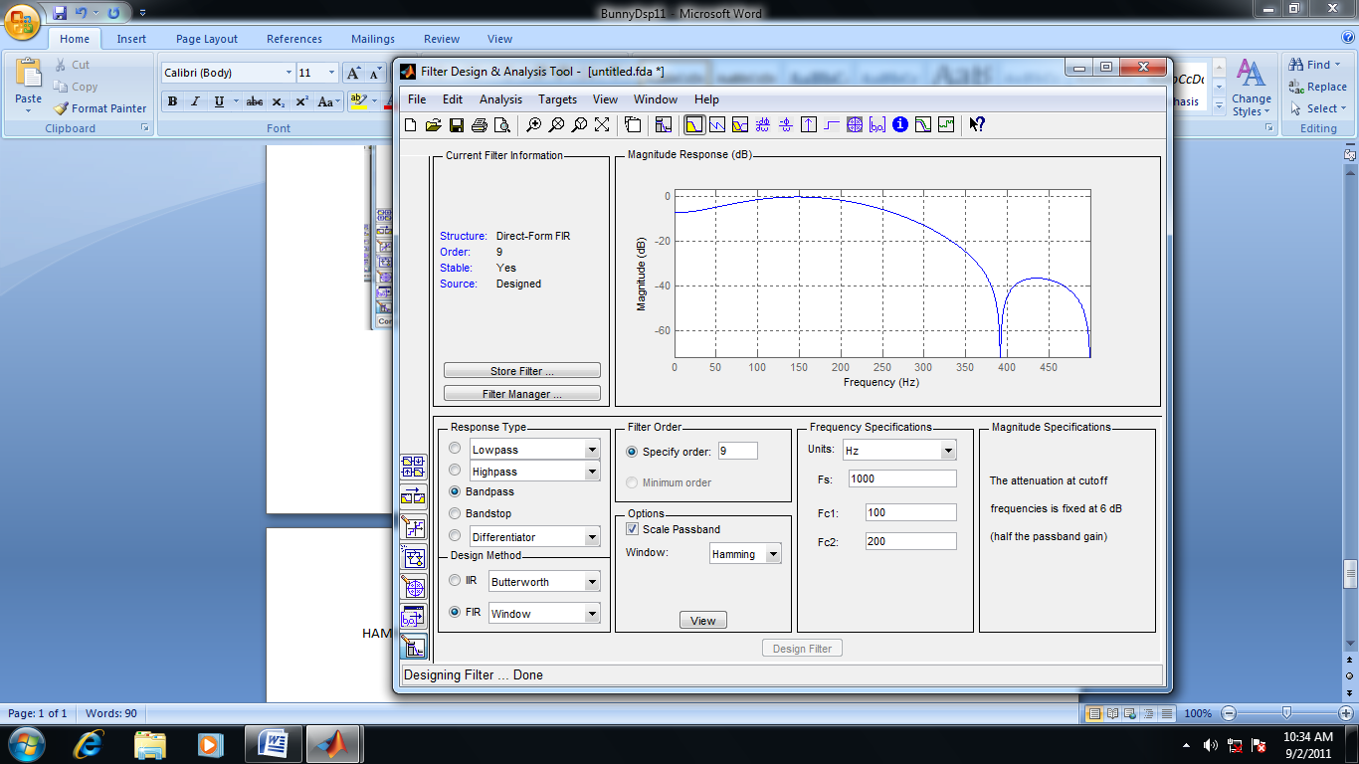**HAMMING:**

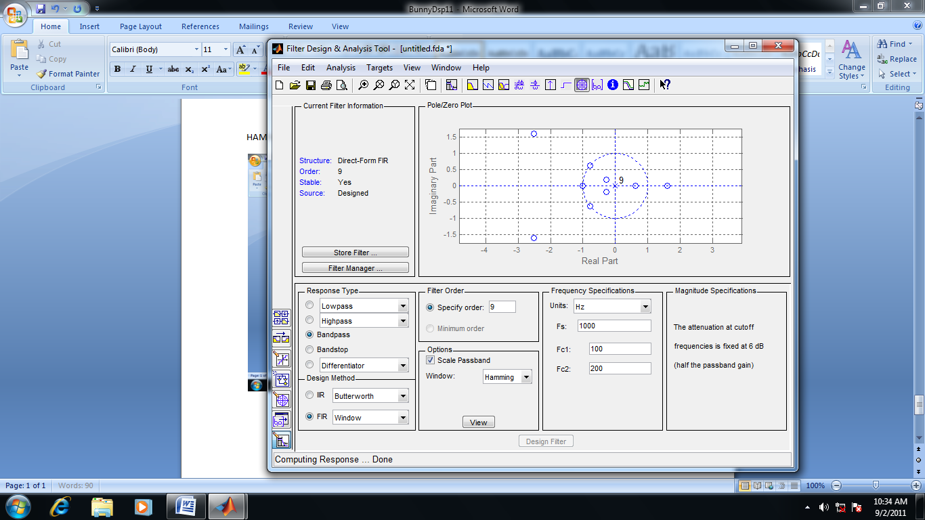

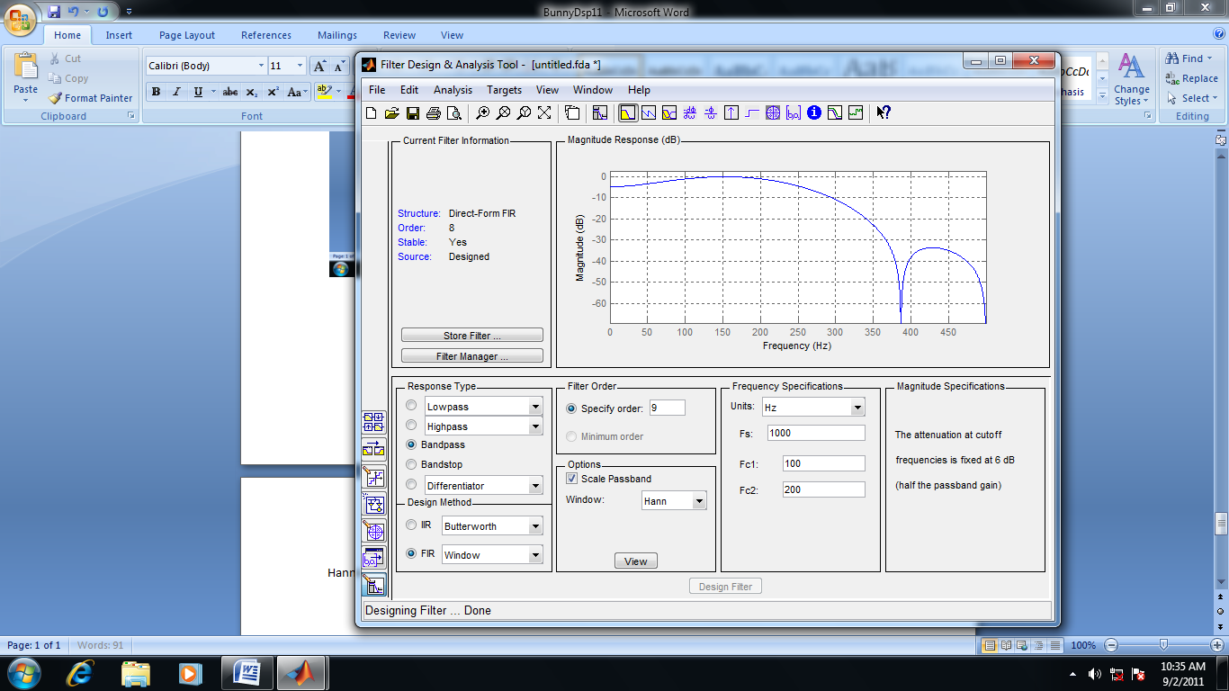**Hanning:**

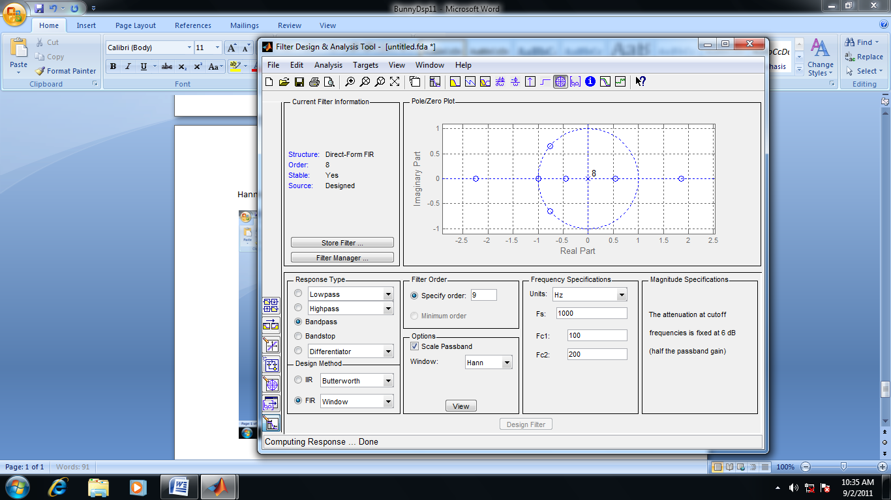

**TASK4:**

Obtain the coefficients of FIR LOW pass filter using equiripple method.

Stop band attenuation = 50 db

Pass band ripple = 0 .05 dB

Fs = 8khz

Fpass = 60khz

Fstop = 3400hz

**FILTER DESIGN & ANALYSIS TOOL:**

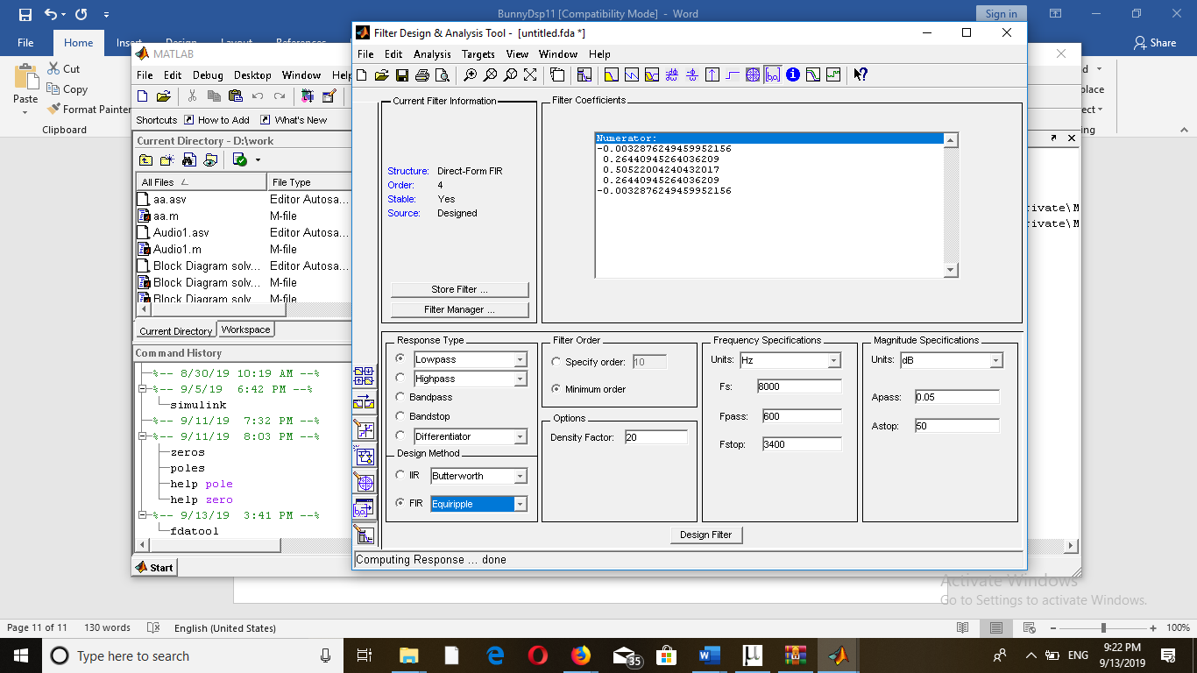**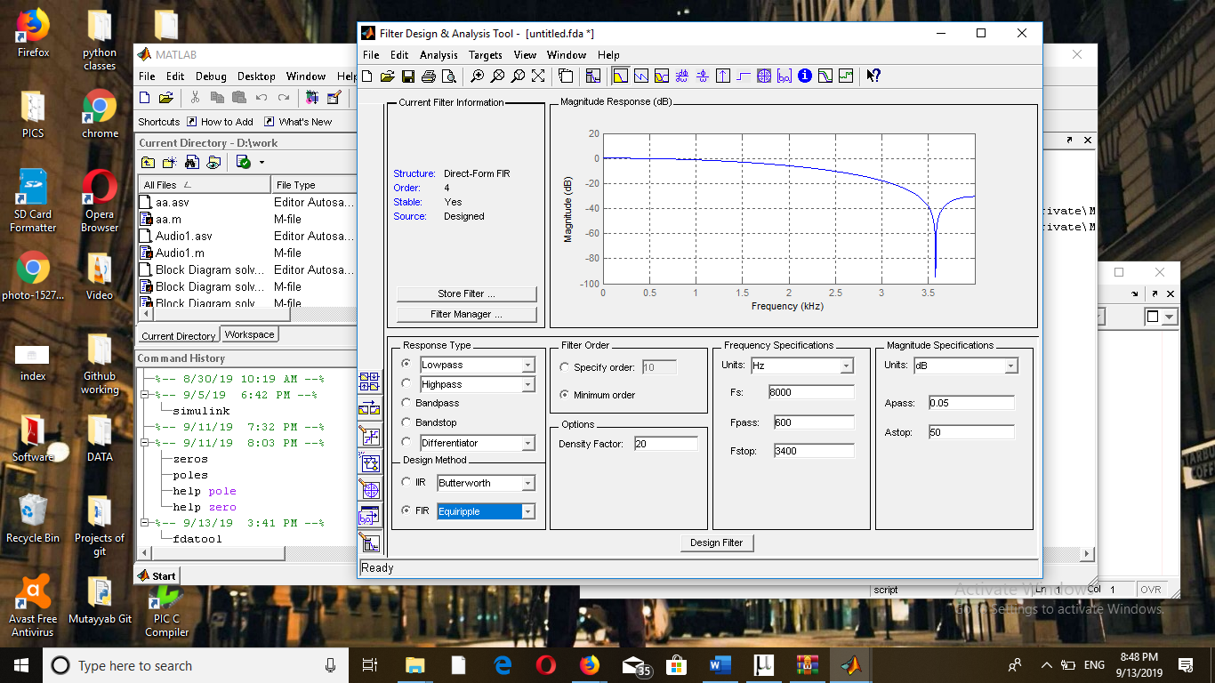Filter Coefficients:**